GOVERNMENT OF NAGALAND

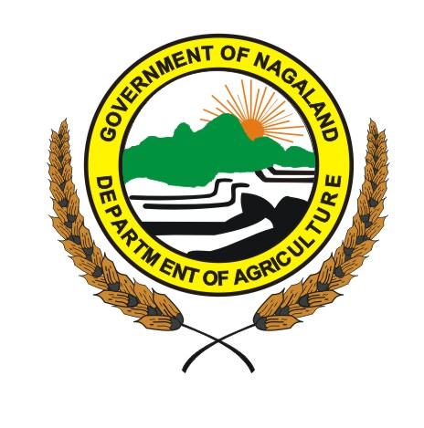

SUO MOTO DISCLOSURES
ON
RIGHT TO INFORMATION ACT 2005
( 2019-20 )

DEPARTMENT OF AGRICULTURE
NAGALAND, KOHIMA.

INDEX

Sl. No. | Content
1 | Particulars of the organization, functions and duties.
2 | Power and duties of officers and employees
3 | Procedure followed in decision making process including channels of supervision and accountability
4 | The norms set for discharge of functions
5 | The rules, regulations, instructions, manuals and records held by it or under its control or used its employees for charging its functions
6 | Statement of categories of documents that are held by it or under its control
7 | The particulars of any arrangement that exists for consultation with, or representation by the members of the public in relation to the formulation of its policy or implementation thereof.
8 | A statement of the boards, councils, committees and other bodies consisting of two or more persons constituted as its part or etc.
9 | Directory of its officer and employees
10 | The Monthly remuneration received by each of its officers and employees, including the system of compensation as provided in its regulation
11 | The budget allocated to each of its agency, indicating the particulars of all plans, proposed expenditure and reports on disbursement made
12 | The manner of execution of subsidy programmes, including the amounts allocated and the details of beneficiaries of such programmes
13 | The particulars of recipients of concessions, permits or authorization granted by it.
14 | The details in respect of information available to or held by it, reduced in an electronic form
15 | The particulars of facilities available to citizens for obtaining information, including the working hours of a library or reading room, if maintained for public use.
16 | The names, designations and other particulars of the Public Information Officers.
17 | Such other information as may be prescribed and thereafter updated every year.

